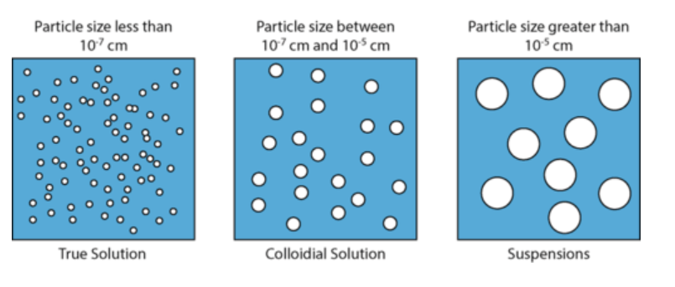

Suspensions

Particle size greater than 10-5 cm

Colloidal Solution

Particle size between 10-7 and 10-5 cm

True Solution

Particle size less than 10-7 cm